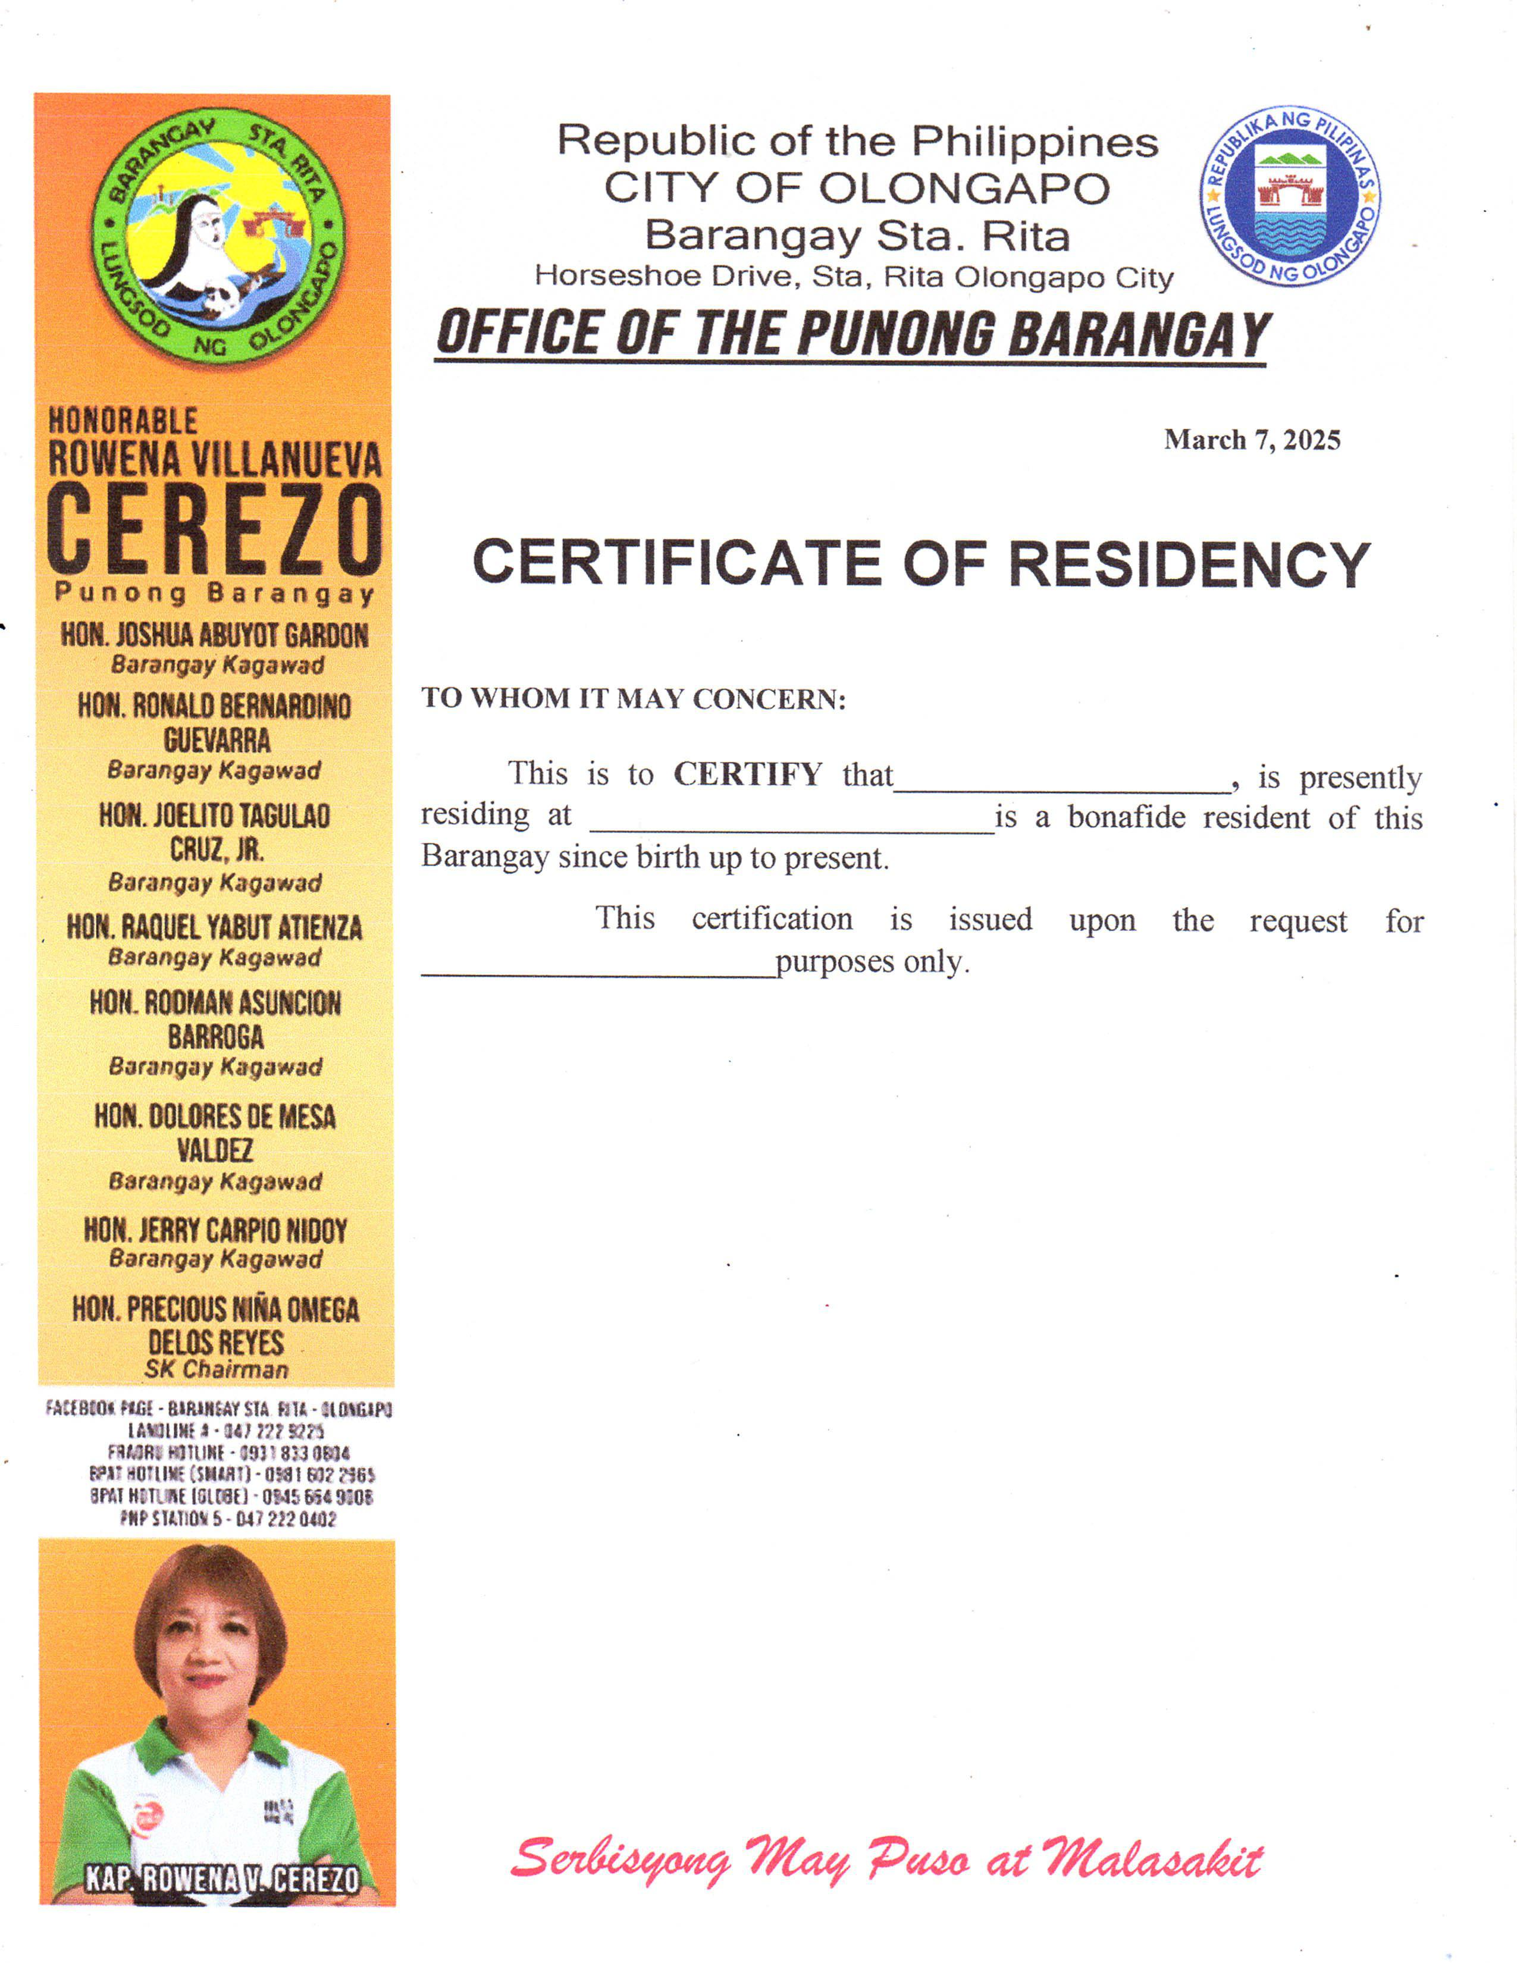 Republic of the Philippines CITY OF OLONGAPO Barangay Sta. Rita Horseshoe Drive, Sta. Rita Olongapo City ***OFFICE OF THE PUNONG BARANGAY***

**March 7, 2025**

BARANGAY INDIGENCY

**TO WHOM IT MAY CONCERN:**

This is to **CERTIFY** that___________________, is presently residing at ____________________ personally appeared in this office and declared that he/she has no sufficient source of income to provide funds for his/her studies.

Further certify that subject person belongs to indigent families of this Barangay

 This **CERTIFICATION** is issued upon the request for ______________________ purposes.

This certificate is valid until October 2025.